**Project Requirements Specification for the Smart Pill dispenser**

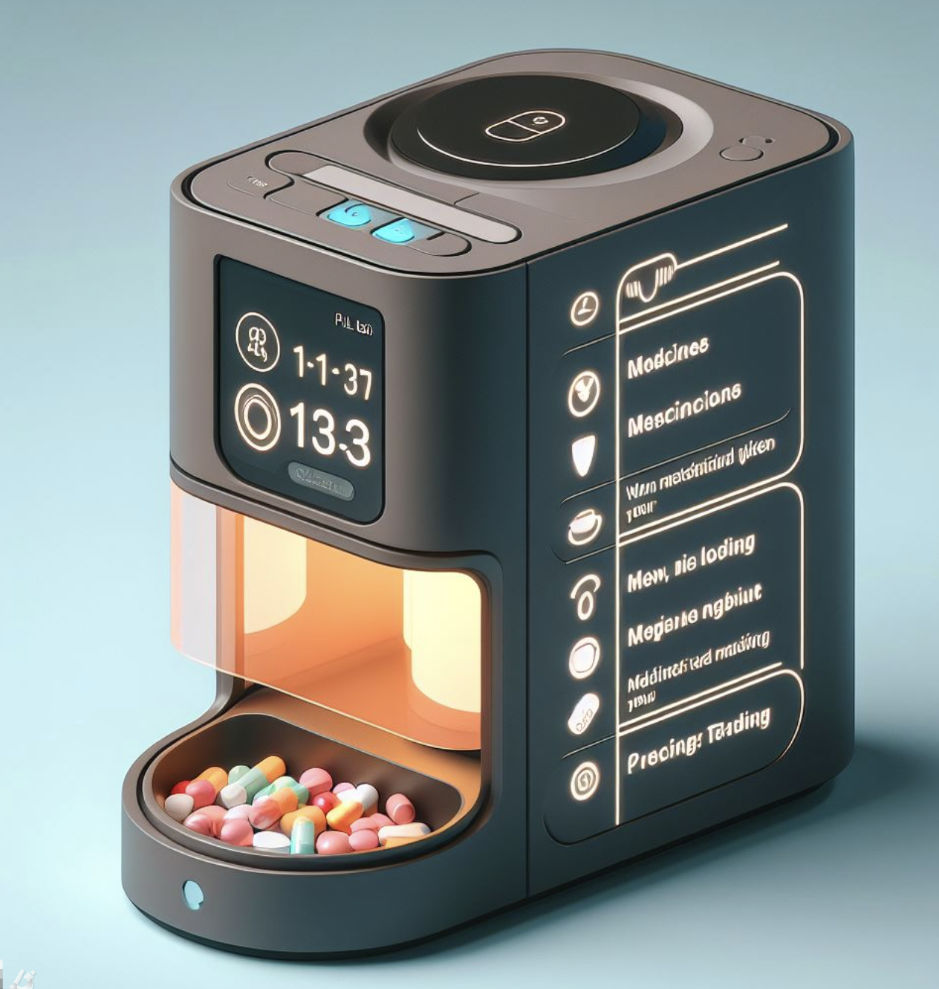

*Volume 1- Scope of the project*

Summary :

**1. Introduction 3**

1.1 Purpose 3

1.2 Scope 3

1.3 Definitions, Acronyms, and Abbreviations 3

1.4 References 3

1.4.1 Electronic Design Documents: 3

1.4.2 Hardware Documents: 4

1.4.3 Software Documents: 4

1.4.4 Regulatory and Compliance Documents: 4

1.4.5 Testing and Validation Documents: 4

1.4.6 User and Maintenance Documents: 4

**2. General Description 5**

2.1 Product Perspective 5

2.2 Product Functions 5

2.3 Constraints 5

**3. Functional Requirements 6**

3.1 User Interface 6

3.2 Data Requirements 6

**4. Non-Functional Requirements 7**

4.1 Performance 7

4.2 Safety 8

4.3 Reliability 8

4.4 Maintainability 9

**5. External Interfaces 10**

5.1 Hardware 10

5.2 Software 11

5.3 Communication 12

**6. Other Requirements 12**

6.1 Regulatory 12

6.2 Environmental 13

# 1. Introduction

## 1.1 Purpose

The purpose of the Smart Pill Dispenser project is to develop an automated system to assist elderly individuals and patients with memory impairments, such as Alzheimer's disease, in taking their medication correctly and on time. The dispenser will be programmed by family members or healthcare providers to dispense the correct medication dosage according to a set schedule. It will alert users with audible and visual signals when it's time to take their medication. If the medication is not taken within five minutes of the alert, the system will notify designated family members or caregivers. This solution aims to enhance medication adherence, reduce the risk of missed or incorrect dosages, and provide peace of mind to caregivers

## 

## 1.2 Scope

The Smart Pill Dispenser project is designed to help elderly individuals and patients with memory impairments, such as Alzheimer's disease, manage their medication effectively.

## 

## 1.3 Definitions, Acronyms, and Abbreviations

* MTBF : Mean Time Between Failures
* OTA: over-the-air

## 1.4 References

The following documents are referenced or will be created to support the development of the Smart Pill Dispenser project. These documents cover various aspects of the project, including electronic design, hardware, software, and regulatory compliance.

### 1.4.1 Electronic Design Documents:

* PCB Design Document: Detailed design specifications for the printed circuit board, including schematics, layout, and component selection.
* Electrical Components Specification: List of all electrical components used in the PCB with their specifications and datasheets.

### 1.4.2 Hardware Documents:

* Mechanical Design Document: Specifications and design details for the physical housing and mechanical components of the dispenser.
* Assembly Instructions: Step-by-step guide for assembling the hardware components.
* Bill of Materials (BOM): Comprehensive list of all materials and components required for the hardware assembly.

### 1.4.3 Software Documents:

* Software Requirements Specification (SRS): Detailed requirements for the software, including functional and non-functional requirements.
* Software Architecture Document: Description of the software architecture, including modules, interfaces, and data flow.
* User Interface Design Document: Specifications for the user interfaces, including screen layouts, user interactions, and navigation flows.
* Software Installation and Configuration Guide: Instructions for installing and configuring the software on the smart pill dispenser and connected devices.
* API Documentation: Detailed description of the Application Programming Interfaces (APIs) used for communication between the dispenser and other systems.

### 

### 1.4.4 Regulatory and Compliance Documents:

* Regulatory Compliance Document: Information on the relevant medical device regulations and standards the product must comply with.
* Data Privacy and Security Requirements: Specifications for data handling, privacy, and security measures to ensure compliance with relevant laws and regulations (e.g., HIPAA).

### 1.4.5 Testing and Validation Documents:

* Testing Plan: Comprehensive plan for testing the electronic, hardware, and software components to ensure they meet the specified requirements.
* Test Cases and Results: Detailed test cases and the results of the testing activities.
* User Acceptance Testing (UAT) Document: Procedures and criteria for user acceptance testing to validate the system with end users.

### 1.4.6 User and Maintenance Documents:

* User Manual: Instructions for end users on how to use the smart pill dispenser.
* Maintenance Guide: Guidelines for maintaining and troubleshooting the device.

# 2. General Description

## 2.1 Product Perspective

The smart pill dispenser enhances healthcare by automating medication management, ensuring consistent and accurate dosing according to prescribed schedules. It integrates with healthcare providers' systems for remote monitoring and intervention, supports caregivers through remote programming and alerts, and generates data for informed decision-making. This integration ensures compliance with medical standards and enhances overall patient care efficiency.

## 2.2 Product Functions

The smart pill dispenser performs the following key functions:

* Automated Medication Dispensing: Dispenses medications at scheduled times, ensuring patients receive the correct dosage at the right time.
* Alert System: Provides audible and visual alerts to remind patients when it's time to take their medication.
* Notification to Caregivers: Sends notifications to caregivers or family members if medications are not taken within a specified timeframe after the alert.
* Remote Programming: Allows caregivers or healthcare providers to remotely program medication schedules and monitor adherence.
* Data Logging: Records medication dispensing and adherence data for review by healthcare providers, aiding in treatment planning and adjustment.
* Alert calls: Making emergency phone calls pressing a visible button in case of any problem to speak with the doctor or family member.

## 

## 2.3 Constraints

The development and implementation of the smart pill dispenser are governed by several constraints:

* Regulatory Compliance: The dispenser must adhere to medical device regulations and standards to ensure safety, efficacy, and data privacy. Compliance with regulations such as FDA guidelines for medical devices is paramount.
* Budgetary Limitations: Development costs must align with a 100€allocated budgets, influencing decisions regarding technology choices, manufacturing processes, and feature implementation.
* Time Constraints: The project timeline is crucial, requiring efficient development, testing, and deployment phases to meet market demands and user needs within specified deadlines.
* Technological Limitations: The design and functionality of the dispenser must align with current technological capabilities, ensuring reliability, interoperability with existing systems, and scalability for future upgrades.
* User Accessibility: The dispenser's interface and operational procedures must accommodate elderly users and those with varying degrees of physical or cognitive impairments, ensuring ease of use and minimizing user error.

# 3. Functional Requirements

## 3.1 User Interface

The user interface (UI) of the smart pill dispenser is designed to be intuitive and accessible, accommodating the needs of elderly users and caregivers:

Elderly Users:

* LED band: Clear and large to see the alerts, and status.
* Audio alerts: Audible alerts with adjustable volume to ensure they are noticeable and easy to understand.

Caregivers and Healthcare Providers:

* Remote Access: Mobile app interface (or web-based) for remote programming of medication schedules.
* Alert Notifications: Instant notifications via the app in case of missed doses or other critical events.
* Data Access: Access to detailed medication adherence reports and patient usage logs for monitoring and adjustment of treatment plans.

## 3.2 Data Requirements

The smart pill dispenser manages and processes the following types of data to ensure effective medication management:

Patient Information:

* Personal Details: Includes patient demographics (e.g., name, age, gender) for identification.
* Medical History: Relevant medical conditions, allergies, and other health-related information to ensure safe medication dispensing.

Medication Schedules:

* Prescribed Regimens: Detailed schedules specifying medication types, dosages, frequencies, and administration instructions.
* Customization: Ability to adjust schedules based on changing patient needs or healthcare provider recommendations.

Adherence Monitoring:

* Usage Logs: Records of medication dispensing events, including timestamps and doses administered.
* Missed Doses: Identification of missed doses or deviations from prescribed schedules, triggering alerts or notifications to caregivers.

Data Privacy and Security:

* Access Controls: User authentication mechanisms to control access to sensitive patient information and system settings.
* Encryption: Data encryption protocols to protect stored and transmitted data from unauthorized access or breaches.

# 4. Non-Functional Requirements

## 4.1 Performance

The smart pill dispenser must meet the following performance requirements:

* Dispensing Accuracy: The system must dispense medications accurately, ensuring the correct type and dosage are delivered according to the programmed schedule with a reliability rate of 99.9%.
* Response Time: Alerts must be delivered promptly, with a response time of less than 5 seconds from the scheduled medication time to alert activation.
* Response Time Notification alters: Notifications must be delivered within 5 min if the pill is still not taken.
* System Availability: The dispenser should be available for use at least 99.9% of the time, allowing for scheduled maintenance and updates without disrupting daily operation. A battery system must be inside ensuring the perfect working of the smart pill dispenser while the power supply is cut.

## 4.2 Safety

Ensuring the safety of users and maintaining the integrity of medication management are paramount for the smart pill dispenser. The following safety requirements must be met:

* Accurate Dispensing: The dispenser must reliably dispense the correct medication type and dosage as programmed, minimizing the risk of dosage errors or incorrect medications being administered.
* Mechanical Reliability: All mechanical components, including the dispensing mechanism and alert system, must function reliably over extended periods to prevent malfunctions that could compromise medication schedules.
* User Alerts and Notifications: Alerts and notifications must be clear, noticeable, and understandable to users, ensuring they are aware of medication schedules and any potential issues promptly.
* Child-Resistant Design: The dispenser should incorporate features to prevent accidental access to medications by children or unintended users, such as secure locking mechanisms.
* Emergency Override: A manual override option should be available for caregivers or healthcare providers in emergency situations, allowing immediate access to medications if needed.
* Compliance with Safety Standards: The dispenser must comply with relevant safety standards and regulations for medical devices to ensure user safety and regulatory compliance.

## 4.3 Reliability

Reliability is essential for the smart pill dispenser to ensure consistent and uninterrupted medication management. The following reliability requirements must be met:

* Uptime: The dispenser should be available for use at least 99.9% of the time, allowing for scheduled maintenance windows without disrupting daily operations.
* Mean Time Between Failures (MTBF): Mechanical components and electronic systems must have a high MTBF, ensuring prolonged operation between failures. Target MTBF should be at least 10,000 hours.
* Fault Tolerance: The dispenser should have built-in fault tolerance mechanisms to handle and recover from unexpected errors or disruptions in operation without compromising medication schedules.
* Backup Power: Include a reliable backup power source (e.g., battery backup) to ensure continuous operation during power outages or disruptions.
* Redundancy: Critical components such as dispensing mechanisms and alert systems should have redundancy built-in to minimize downtime and ensure uninterrupted functionality.
* Testing and Validation: Conduct rigorous testing and validation procedures during development and deployment phases to identify and mitigate potential reliability issues before deployment.
* Monitoring and Maintenance: Implement proactive monitoring systems to detect performance degradation or potential failures early, allowing for timely maintenance and repairs.

## 4.4 Maintainability

Maintainability is crucial for ensuring the smart pill dispenser can be efficiently serviced, updated, and repaired throughout its lifecycle. The following maintainability requirements should be implemented:

* Modular Design: The dispenser should be designed with modular components that can be easily replaced or upgraded without requiring extensive reconfiguration of the entire system.
* Documentation: Provide comprehensive documentation, including user manuals, service guides, and technical documentation for maintenance personnel and end-users.
* Remote Diagnostics: Implement remote diagnostic capabilities to allow troubleshooting and identification of issues without requiring physical access to the device. (optional)
* Software Updates: Ensure the dispenser supports over-the-air (OTA) software updates to deploy bug fixes, security patches, and new features seamlessly.
* Spare Parts Availability: Maintain a supply of spare parts and components to facilitate quick replacement and repair of faulty hardware components.
* Vendor Support: Establish a reliable support network with the vendor or manufacturer to address complex technical issues and provide ongoing support and maintenance.

# 

# 5. External Interfaces

## 5.1 Hardware

The smart pill dispenser interacts with various hardware components to ensure accurate medication management and user interaction. The following hardware interface requirements should be addressed:

Medication Containers:

* Compatibility: Interface with standard medication size (small, medium, large) to accommodate different types of medications.
* Sensor Integration: Incorporate sensors or indicators to detect and confirm the presence of medications in containers before dispensing.

Dispensing Mechanism:

* Accuracy: Ensure precise dispensing of medications with adjustable dosing capabilities to accommodate varying prescription requirements.
* Reliability: Mechanism should operate reliably over extended periods without mechanical failures or dispensing errors.

User Interface Devices:

* LED: Utilize a LED strip to make sure that the alert signal is visible.
* Buttons Controls: Include large buttons for the emergency call.

Connectivity Modules:

* Wi-Fi: Integrate Wi-Fi or Ethernet connectivity for communication with external systems such as caregiver apps, healthcare databases, and remote monitoring platforms.
* Bluetooth: Support Bluetooth connectivity for local interactions with mobile devices for data synchronization and software updates.

Power Supply:

* Backup Power: Include a reliable backup power source (e.g., battery backup) to maintain operation during power outages or interruptions.
* Power Management: Optimize power consumption to extend battery life and reduce dependency on external power sources.

Security Features:

* Locking Mechanism: Implement a secure locking mechanism to prevent unauthorized access to medication compartments.
* Tamper Detection: Include tamper detection sensors or mechanisms to alert users and caregivers of any attempted tampering or unauthorized access.

Physical Dimensions and Design:

* Compact Design: Ensure a compact and ergonomic design that fits easily on a bedside table or medication storage area without occupying excessive space like a coffee machine.
* Durability: Construct the dispenser with durable materials resistant to wear and tear, ensuring longevity and reliability in healthcare environments.

## 5.2 Software

The smart pill dispenser relies on software interfaces to facilitate efficient operation, communication, and data management. The following software interface requirements should be addressed:

Mobile App Integration:

* Platform Compatibility: Develop mobile applications compatible with iOS and Android platforms for remote management by caregivers.
* Functionality: Enable caregivers to program medication schedules, receive alerts, and monitor adherence through the mobile app interface.

Web Portal:

* Secure Access: Provide healthcare providers with secure access to a web portal for viewing medication adherence reports, patient data, and system status updates.
* Integration: Integrate with existing healthcare information systems (e.g., electronic health records) for seamless data exchange and patient management.

Communication Protocols:

* APIs: Define APIs for integration with external systems such as telehealth platforms, enabling data sharing and interoperability.
* Data Synchronization: Implement protocols (e.g., RESTful APIs) for real-time data synchronization between the dispenser and external databases or applications.

Data Management:

* Data Storage: Store medication schedules, user preferences, and adherence data securely within the dispenser's database.
* Backup and Recovery: Implement mechanisms for regular data backups and recovery procedures to prevent data loss in case of system failure.

Software Updates:

* OTA Updates: Support over-the-air (OTA) software updates to deploy bug fixes, security patches, and new features seamlessly to the dispenser and associated applications.

Security Measures:

* Encryption: Encrypt sensitive data transmitted between the dispenser, mobile apps, and web portals using robust encryption standards (e.g., AES-256).
* Authentication: Implement secure authentication mechanisms (e.g., OAuth) for user access control and protection against unauthorized access.

## 5.3 Communication

The smart pill dispenser utilizes robust communication interfaces to ensure seamless data exchange and interaction with external systems:

* Wi-Fi Connectivity: Enables the dispenser to connect to local networks for data synchronization, software updates, and remote monitoring by caregivers or healthcare providers.
* Bluetooth: Supports short-range communication with mobile devices, facilitating setup, configuration, and data transfer between the dispenser and caregiver apps.
* API Integration: Provides Application Programming Interfaces (APIs) for integration with healthcare databases, electronic health records (EHRs), and telehealth platforms, enabling secure data exchange and interoperability.

# 6. Other Requirements

## 6.1 Regulatory

The smart pill dispenser must comply with relevant regulatory standards and requirements to ensure safety, efficacy, and legal compliance:

* Medical Device Regulations: Adhere to regulations applicable to medical devices, such as FDA regulations in the United States or CE marking requirements in the European Union, ensuring the dispenser meets safety and performance standards.
* Data Protection Regulations: Comply with data protection laws and regulations, such as GDPR in Europe or HIPAA in the United States, to safeguard patient information and ensure secure data handling practices.
* Quality Standards: Implement quality management systems (e.g., ISO 13485) to ensure consistent product quality, reliability, and traceability throughout the manufacturing and distribution processes.
* Labeling and Instructions for Use: Provide clear and comprehensive labeling and instructions for use (IFU) that comply with regulatory requirements, ensuring safe and effective operation of the dispenser by users and caregivers.
* Post-Market Surveillance: Establish mechanisms for post-market surveillance, including monitoring of adverse events, user feedback, and continuous improvement processes to maintain product safety and efficacy.

## 6.2 Environmental

The smart pill dispenser must operate effectively within specified environmental conditions to ensure reliable performance and longevity:

* Temperature Range: Operate within a temperature range suitable for typical indoor environments (e.g., 10°C to 40°C) to prevent overheating or malfunctioning of electronic components.
* Humidity Levels: Maintain functionality in moderate humidity levels (e.g., 30% to 70% relative humidity) to prevent moisture-related damage and ensure operational reliability. (optional)
* Storage Conditions: Specify storage conditions (e.g., temperature, humidity) for unused or spare parts to maintain their integrity and functionality over extended periods.
* Transportation and Handling: Design packaging and handling procedures to protect the dispenser during transportation and storage, ensuring it arrives at its destination intact and operational.
* Durability and Resistance: Construct the dispenser with materials and coatings resistant to wear, corrosion, and environmental factors (e.g., dust, vibrations) encountered in healthcare settings.
* Power Requirements: Ensure compatibility with different power sources and voltages commonly found in healthcare facilities, including provisions for backup power during power outages.
* Environmental Impact: Consider the environmental impact of the dispenser's materials and manufacturing processes, aiming for sustainability and compliance with relevant environmental regulations.